# Media Analysis - ChatGPT outperforms copywriters in STEP Conference’s outdoor adverts _ Updated 22 February 2023

## Short Summary

The article is about how ChatGPT outperformed a team of copywriters in creating effective outdoor adverts for the STEP Conferences tech festival, leading the company to plan continued use of the AI tool.

## Summary

Here is a summary of the text in exactly 4 bullet points:  
  
* ChatGPT outperformed copywriters at STEP Conferences, prompting the company to use the AI tool for creating outdoor adverts and other content.  
* The company's founder, Ray Dargham, stated that ChatGPT was used to generate taglines, which were then designed into ads by their agency.  
* STEP Conference plans to continue using ChatGPT and acquire at least one paid account for the team to use in creating, summarizing, and explaining content.  
* Dargham believes that AI tools like ChatGPT will both complement and replace human talent, but also thinks that human creativity will always be valuable.

## Question 1

The media frames the public discussion about ChatGPT as a potential replacement for human talent, particularly copywriters. The metaphor of threat is used to describe AI-powered chatbots like ChatGPT, with quotes such as existential threat posed by them . The article also uses metaphors such as brings out much better , implying that ChatGPT s output is superior to humans .

## Question 2

The text covers the following perspectives and aspects **Perspectives and aspects being covered ** * ChatGPT s performance in creating effective outdoor adverts for STEP Conferences * The company s plan to continue using ChatGPT due to its efficiency and effectiveness * Potential job displacement of copywriters by AI tools like ChatGPT * The complementary role of AI tools, rather than replacing human talent **Aspects being ignored ** * No discussion on the potential risks or downsides of relying heavily on AI-generated content * No exploration of alternative solutions to using ChatGPT for creating adverts and content * Limited consideration of the long-term impact on the creative industry as a whole.

## Question 3

The role of the Arabic World is Not mentioned . There is a mention that Arab News is an organization cited as a source, but the topic itself does not pertain to the region or its leveraging of AI.

## Question 4

The future of creative industries may see AI tools like ChatGPT complement and replace human talent, but also create new jobs that don t exist yet.

## Sentiment

The sentiment is 3.0

## Entities

Art, Dargham, Googles Bard, Ray Dargham, STEP Conference, Dargham clari ed, STEP, Metas Open Pretrained Transformer, Microsofts Bing, Arab News, STEP Conferences

## Highlights

#7cc867: 12

#f9cd59: 16

#c885da: 12

#fb5b89: 12

## Wordcloud for #7cc867 Highlights

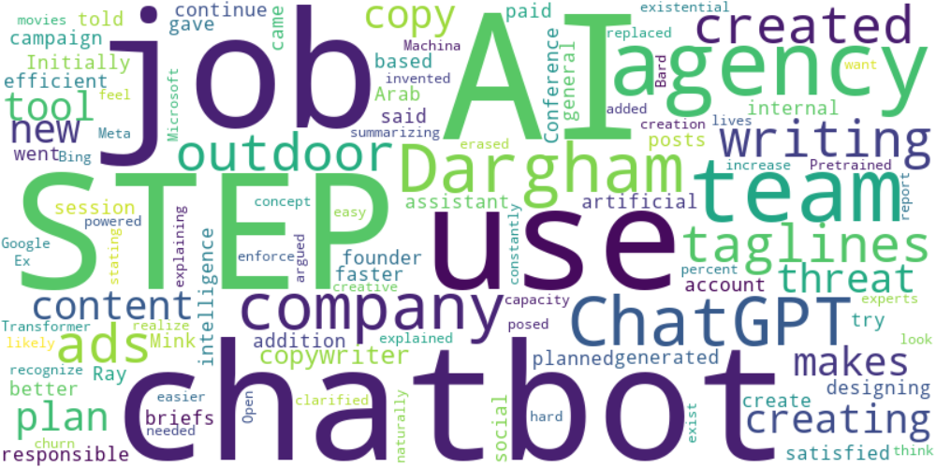

Top 10 words:

- AI: 6

- STEP: 5

- use: 4

- agency: 4

- team: 4

- like: 4

- Dargham: 3

- ChatGPT: 3

- company: 3

- chatbots: 3

## Wordcloud for #f9cd59 Highlights

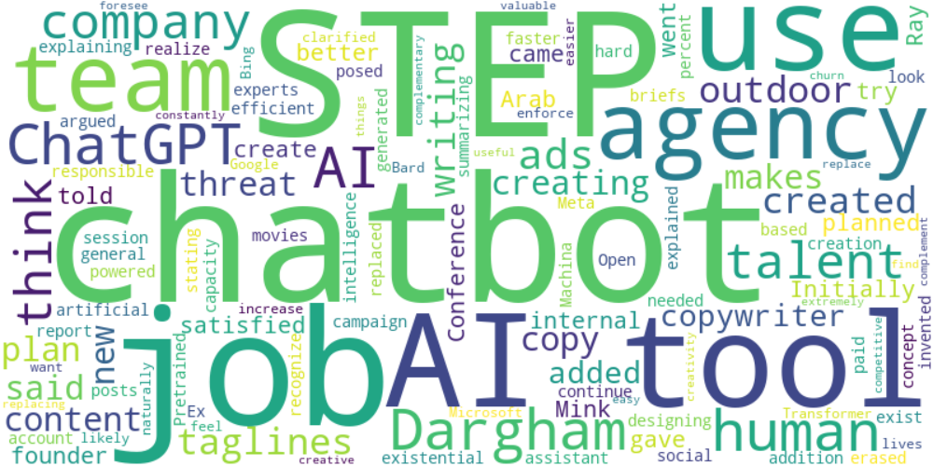

Top 10 words:

- AI: 9

- STEP: 5

- use: 4

- agency: 4

- team: 4

- Dargham: 4

- ChatGPT: 4

- like: 4

- tools: 4

- company: 3

## Wordcloud for #c885da Highlights



Top 10 words:

- AI: 6

- STEP: 5

- use: 4

- agency: 4

- team: 4

- like: 4

- Dargham: 3

- ChatGPT: 3

- company: 3

- chatbots: 3

## Wordcloud for #fb5b89 Highlights



Top 10 words:

- AI: 6

- STEP: 5

- use: 4

- agency: 4

- team: 4

- like: 4

- Dargham: 3

- ChatGPT: 3

- company: 3

- chatbots: 3